- Purpose
  - The purpose of this document is to describe the procedure for prepping and checking a Genie B machine before shipment.
- Scope
  - This SOP applies to all equipment assembly team members. The process applies to the following machine ID’s:
E083039EQM0600BE1200 – Genie B APS 14” Automatic Scrubber
- Responsibilities
  - The operations manager/supervisor is responsible for enforcing this SOP.
- Materials
  - The proper materials needed for this process are listed on the machine work order.
- Definitions

- Procedure
  - Begin by taking a base machine (88028) out of the box. Set all of the components aside (Brush, tank, tanks lid, and cord) that come with it. Put the handle into the upright position.

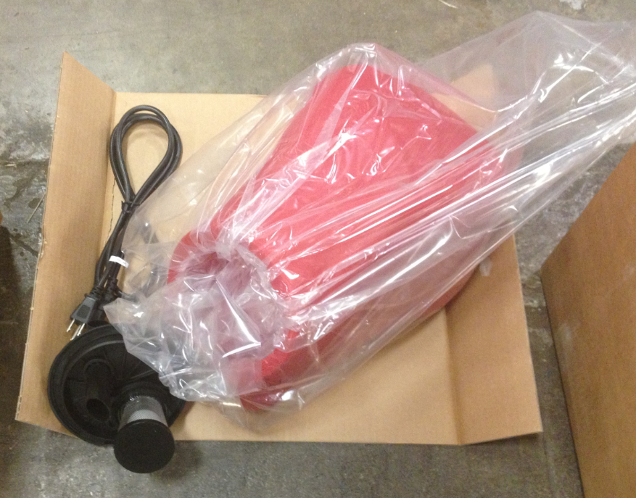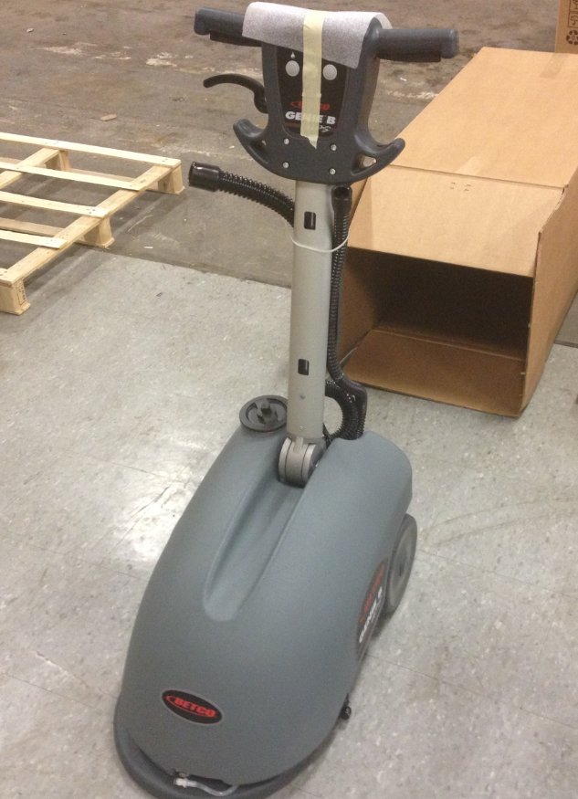

  - Disconnect the fitting at the front of the solution tank and remove the tank from the machine.

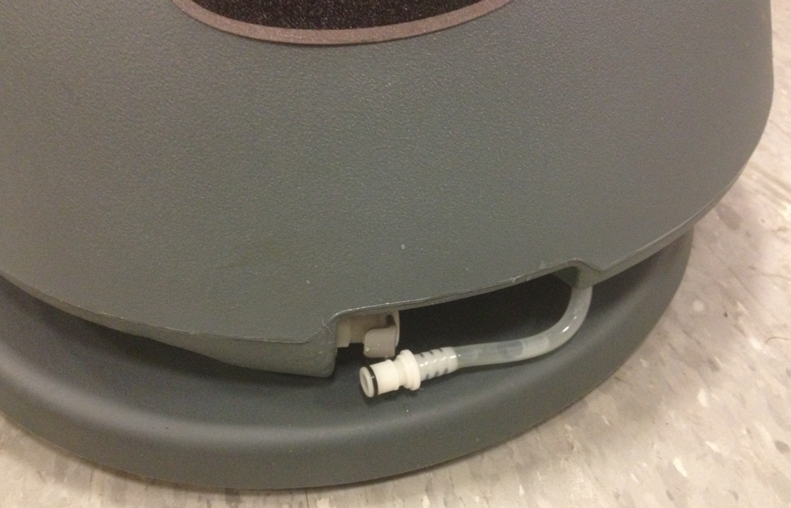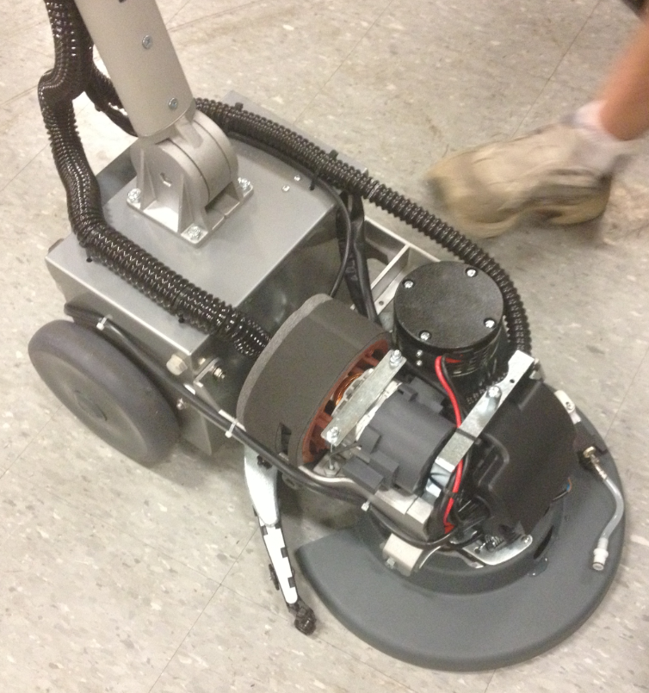
  - Move the zip tie up and lift the squeegee assembly off of the floor to keep it clean.

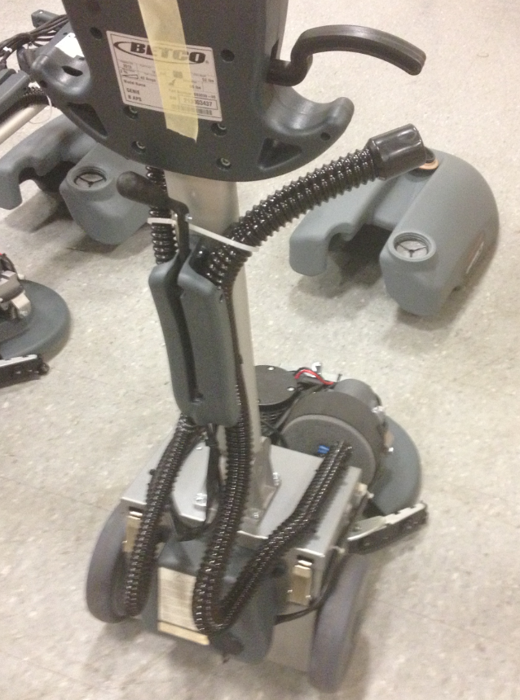

  - Open the battery box by unlocking that latches that hold the box closed. Remove the pigtail.

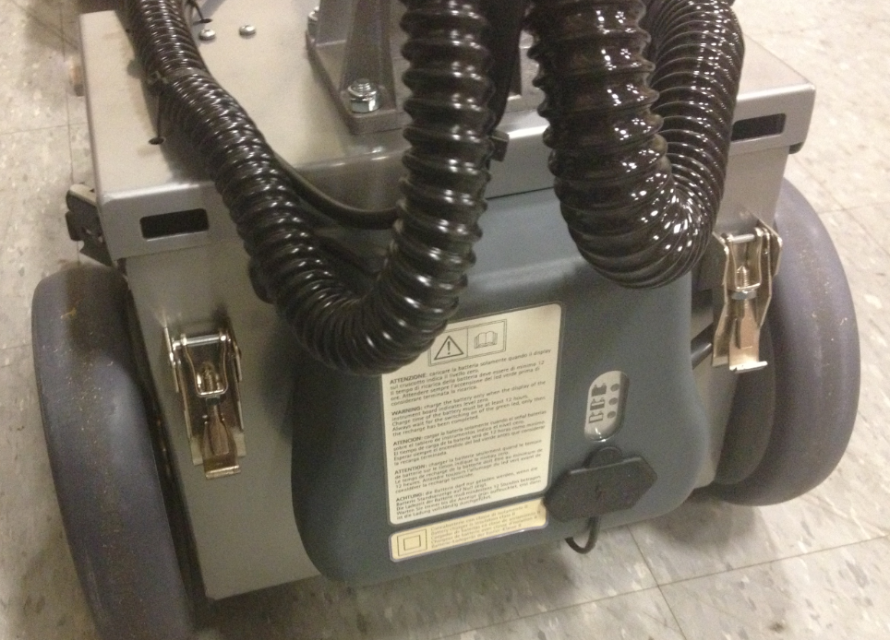

  - Place a battery (88029) into the battery box as shown.

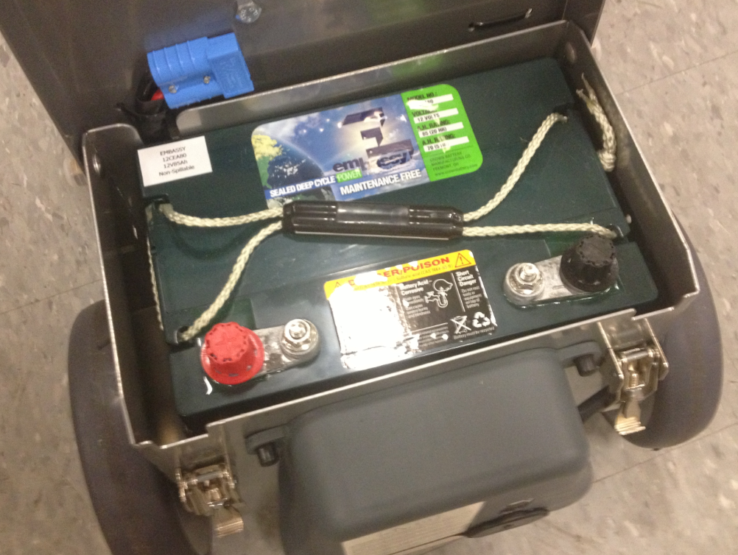
  - Place a Maintenance Free Battery (88897) sticker onto the battery as shown.

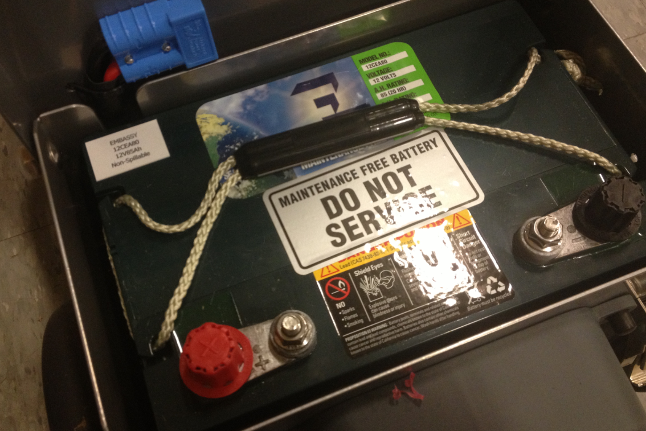

  - Connect the pigtail to the battery terminals. Be sure to connect the positive and negative terminals correctly. Spray some battery terminal protectant onto the terminals and place the covers over them.

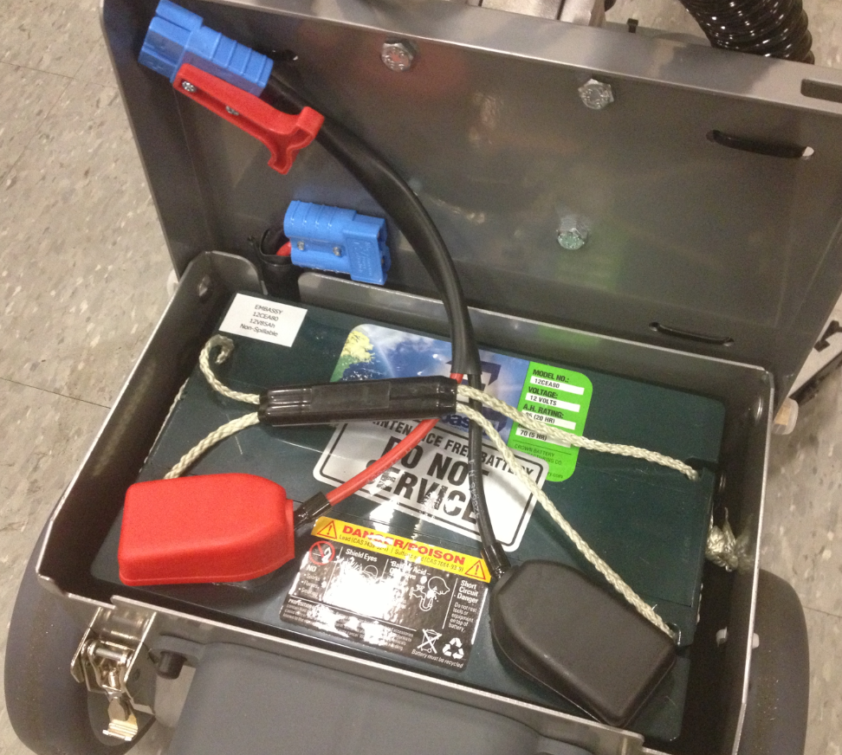

  - Check the lugs on each battery connector to verify that they are positioned properly. Occasionally the lugs may be out of alignment, causing a bad connection. The connectors should essentially “click” together. Connect the battery connector to the machine as shown.

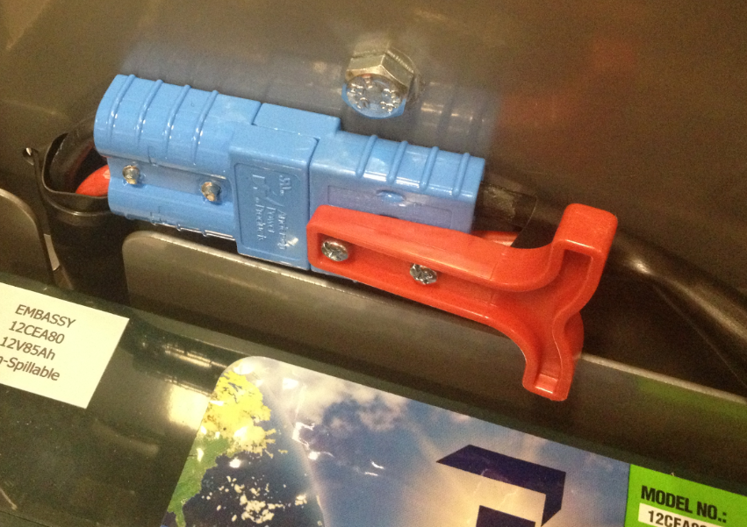
  - Close the battery box and latch it. One latch is sufficient at this point.

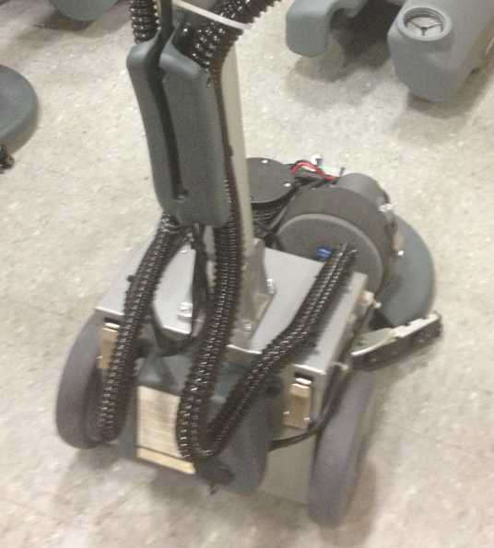

  - Place the solution tank back onto the machine and re-connect the fitting on the front. Pour about 1/5 gallon of fluid into the tank.

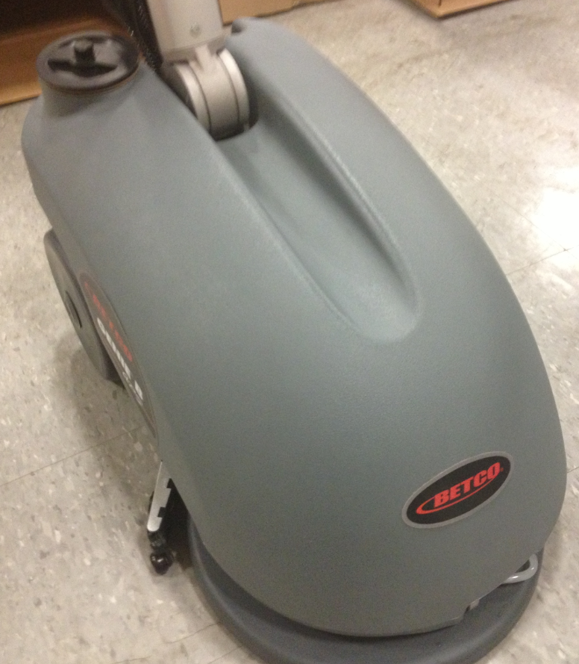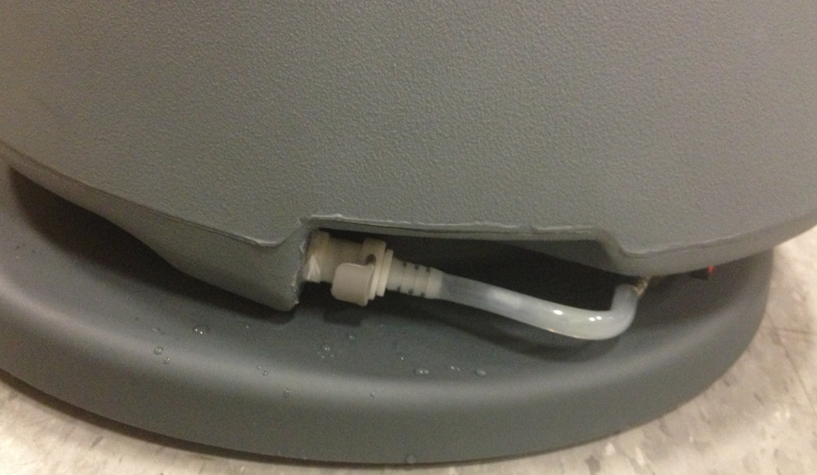

  - Turn the machine on by pressing the button with the picture of the brush. The battery indicator will come on and should read “4”. Allow the machine to sit for a couple minutes to verify that the number does not drop below “4”. If it does the battery will need replaced.

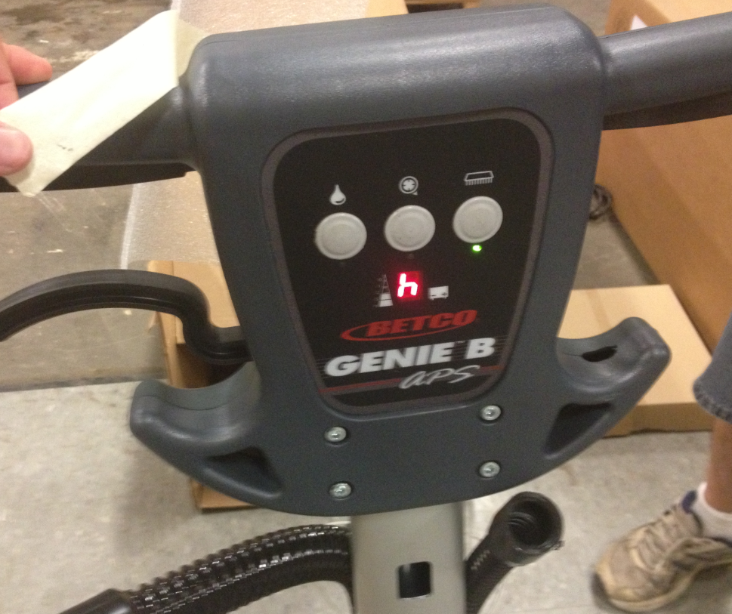
  - Press the Vacuum button and verify that the vac motor turns on. Place your hand over the end of the hose to verify that it has proper suction. Allow the vac motor to run for about 45 seconds. You should not see the battery indicator go from 4 to 3. Turn the vac motor off once everything checks out.

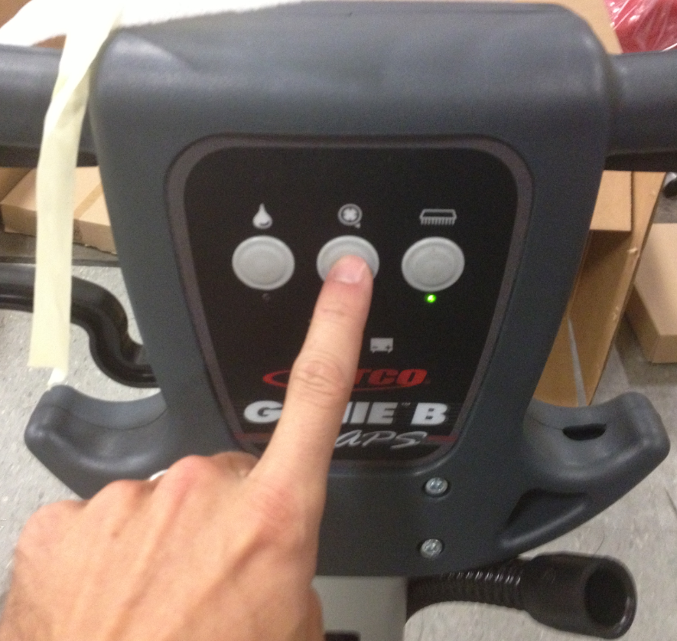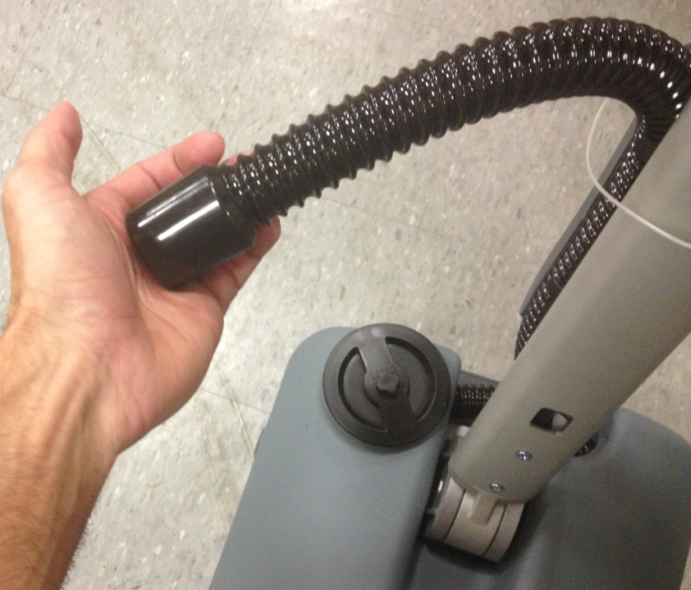

  - Use the test brush to verify that the machine properly picks up and drops that brush. Actuate the brush motor using the triggers on the handle. Slightly bend the tabs on the clutch plate if the brush sticks. The machine should pick up and drop the brush automatically by pulsing the motor.

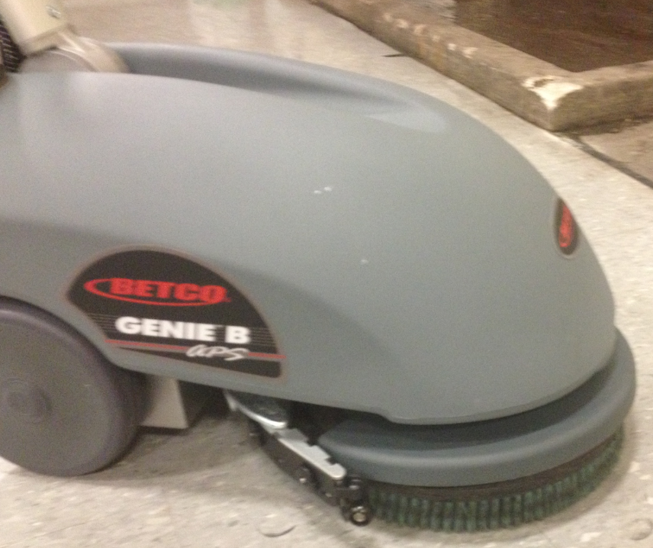

  - Press the solution flow button to activate the solenoid. Press the triggers to allow the solution to flow. Verify that the proper flow occurs.

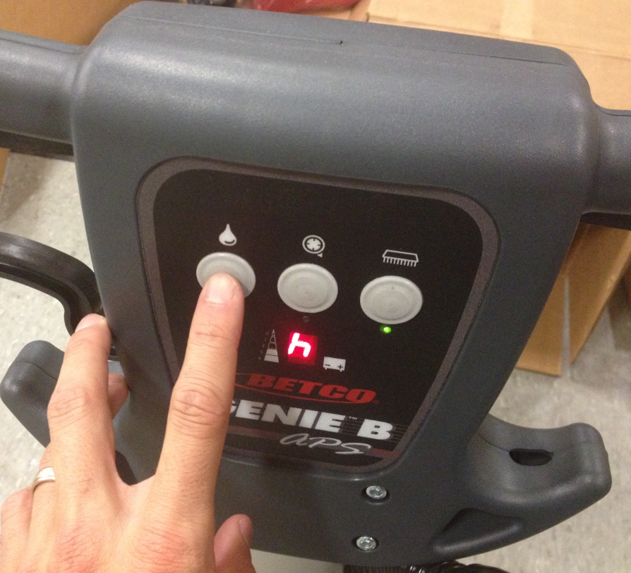

  - Turn off the solution flow followed by the brush motor by pressing the appropriate buttons. This will turn off power to the machine.
  - Open up the battery compartment and disconnect the battery. Be sure to latch the battery compartment closed when complete.

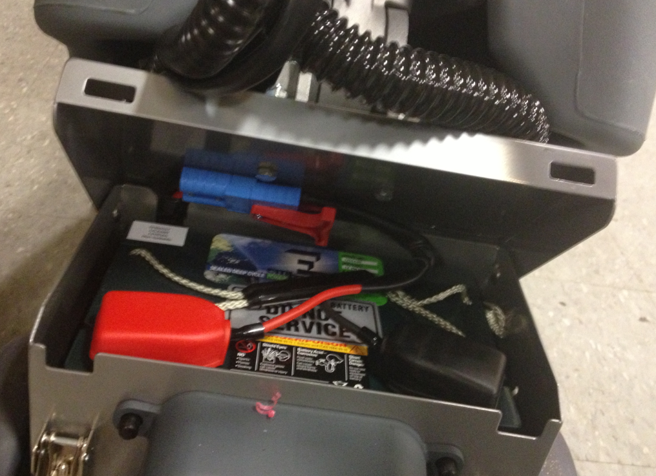

  - Lower the squeegee assembly back down. Place the zip tie back over the handle to hold it in place.

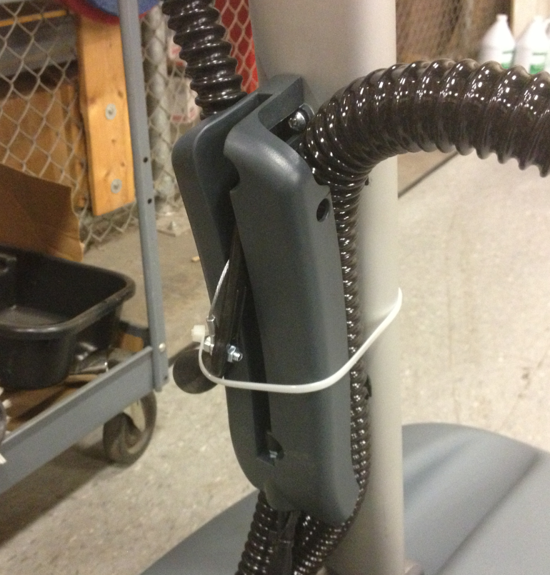

  - Pull the plunger on the lid of the solution tank. This will keep the solution from leaking out as the machine is shipped.

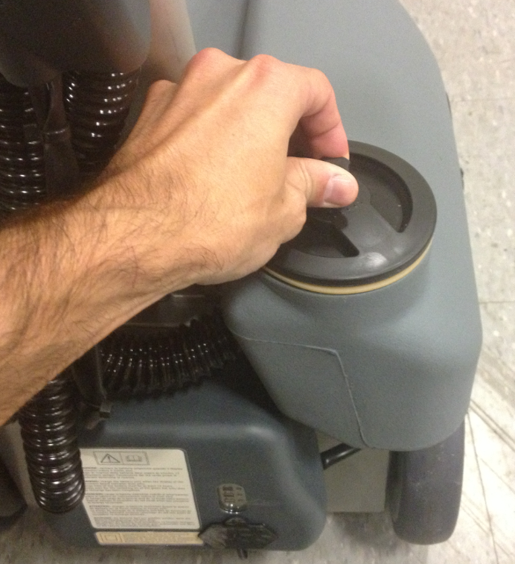

  - Lower the handle into the “down” position.

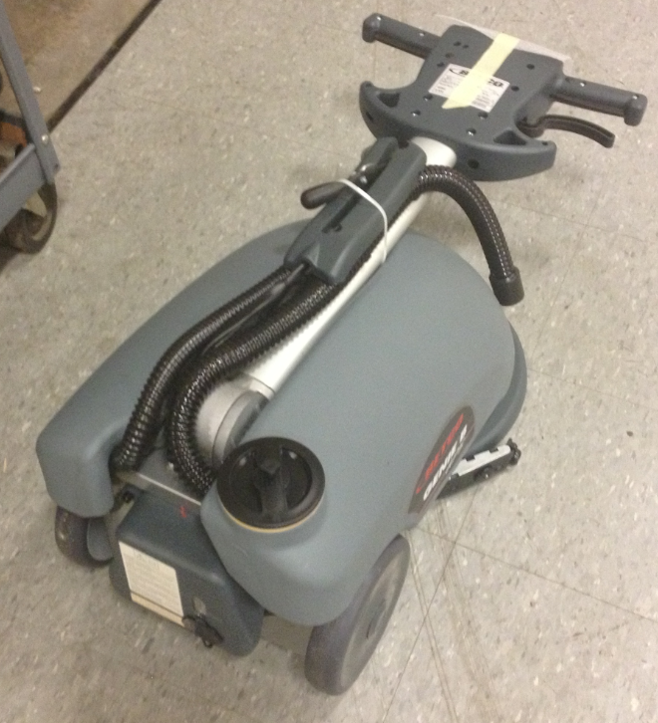

  - Roll the machine back into the box and stand it up.
  - Slide the brush into the box into the location shown.

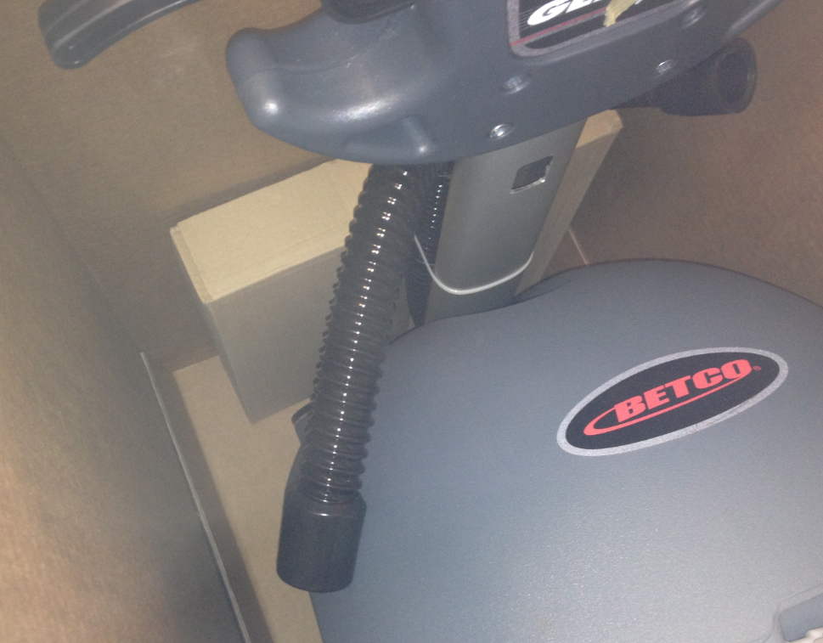

  - Place the recovery tank, tank lid, and cord back into the box. Put together a manual package with a manual, a yellow QC tag, and a warranty card and place that into the box.

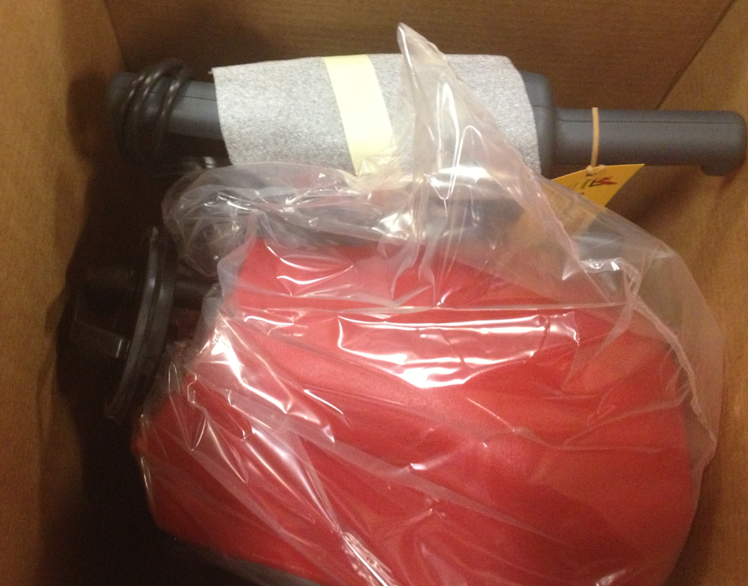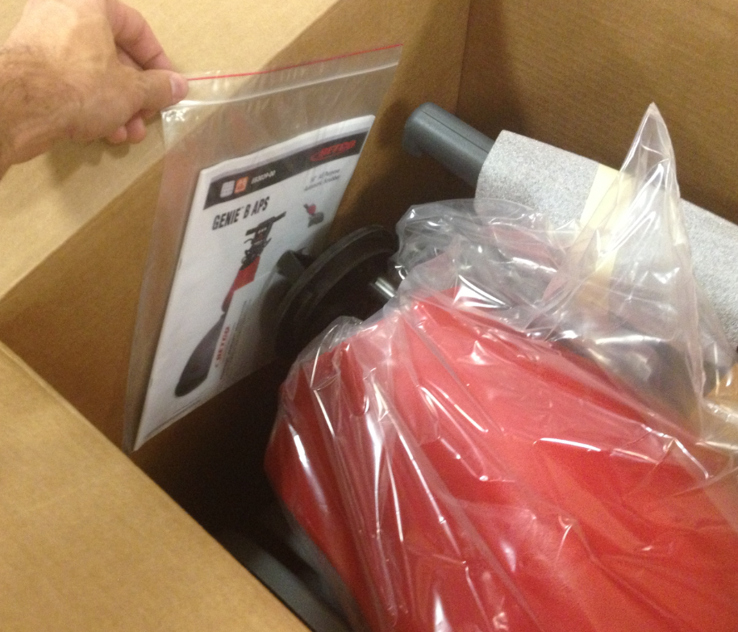

  - Put the insert back into the box and tape the box shut.

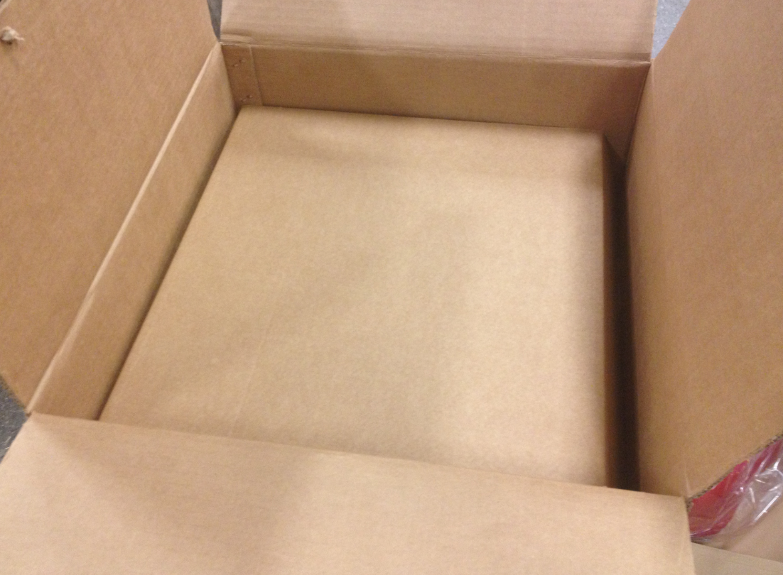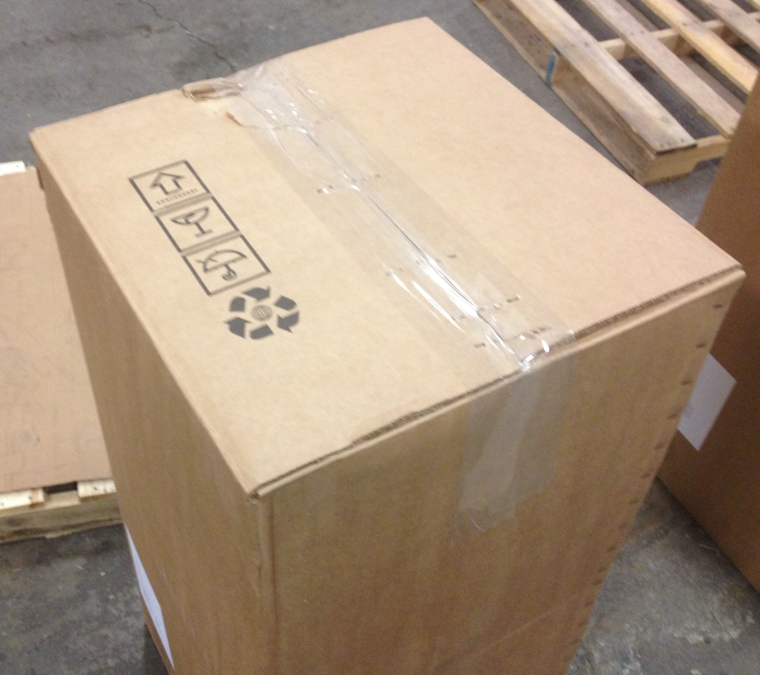

  - Place a barcode sticker over the old inventory ID on the label.

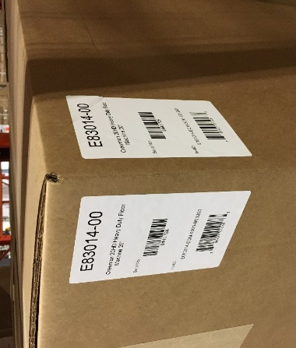

  - The machine is now ready for shipment.

- References (optional section as needed)

- Training Guide

Functional Training Groups Requiring Training
Equipment Group

- SOP Change Control

Date of Change | Reason for Change
Rev 01 - 12/6/2013 | This is the first version of the S.O.P. hence there are no revisions to this document.
Rev 02 - 1/26/2018 | Added the Responsibilities Section
Rev 03 - 5/6/2025 | Removed QR code stickers

Approvals

Submitter/Author Approval:__________________________________ Date:______________________

Management Approval:______________________________________ Date:______________________

QAU Approval:_____________________________________________ Date:______________________

